

**PROJECT INITIATION DOCUMENT**

*Project: Virtualisation*

|  |  |  |  |
| --- | --- | --- | --- |
| **Client: Plaintech** |  | **Filename:** | PID team 1 Project Virtualisation.docx |
| **Project: Virtualisation** |  | **Version:** | 0.7 |
| **Author: Willem Westerhof, Pieter Dieleman, Eddy van der Steen, Kjell Zijlemaker, Rodney Lanuzga** |  | **Date:** | 17-09-2014 |

# Documentproperties

## History

|  |  |  |  |  |
| --- | --- | --- | --- | --- |
| **Version** | **Date** | **Changes(concept/final)** | **Client** | **Author(s)** |
| 0.1 | 3-9-2014 | Translation template to english | Plaintech | Willem Westerhof |
| 0.2 | 8-9-2014 | Adding chapters to the PID | Plaintech | All teammembers |
| 0.3 | 10-9-2014 | Adding chapters to the PID | Plaintech | All teammembers |
| 0.4 | 13-9-2014 | Updated the business case and project definition. | Plaintech | Pieter Dieleman |
| 0.5 | 16-9-2014 | Updated the PID | Plaintech | All teammembers |
| 0.6 | 17-9-2014 | Grammar check | Plaintech | Eddy |
| 0.7 | 17-9-2014 | 2nd grammar check and lay out | Plaintech | Willem |
| 0.8 | 17-9-2014 | Appendixes added | Plaintech | All teammembers |
| 1.1 | 03-10-2014 | Updated business case | Paintech | Pieter Dieleman, Kjell Zijlemaker, Willem Westerhof |
| 1.2 | 10-11-2014 | Updated business case | Plaintech | Pieter Dieleman |

## Approval

This document needs the following signatures of approval:

|  |  |  |  |  |
| --- | --- | --- | --- | --- |
| **Name** | **Role** | **Autograph** | **Document Date** | **Version** |
| Arjen Jansen | Project manager |  | 16-9-2014 | 0.5 |
| CEO/CFO | Client |  | 16-9-2014 | 0.5 |

# Management summary

Plaintech is a hosting company stationed in the UK. In the last few years it grew into an internationally known hosting  with around 50000 customers.  
As IT technology has changed over the years, Plaintech's infrastructure hardware for hosting has become outdated, which has resulted in higher than necessary costs.

Plaintech has contacted Itopia, with a request for proposal, to build a new hosting infrastructure to hold virtual servers for new and existing customers.

Itopia has started Project Virtualization in order to assist Plaintech to create the most efficient infrastructure. This way their costs will be reduced and their investment will be earned back in a short amount of time.

During the project Itopia created the Project Initiation Document. The Project Initiation Document contains a detail overview of the plans and agreements that have been made between Itopia and Plaintech.

The deliverables contains the following items:

* Technical Design
* Functional Design
* Implementation plan
* Proof of Concept
* Prototype

Below you will find a schedule with the deliverables and the final date that it will be delivered.

|  |  |
| --- | --- |
| Deliverables | Final delivery date |
| Project initiation Document | 5 January 2015 |
| Functional design | 5 January 2015 |
| Technical Design | 5 January 2015 |
| First prototype | 21 October 2014 |
| Updated prototype | 11 November 2014 |
| Updated prototype | 1 December 2015 |
| Updated prototype | 5 January 2015 |

# Table of Contents

Documentproperties

History

Approval

Management summary

Table of Contents

1. Introduction

1.1 Using the PRINCE2 project management method

1.2 Goal of this document

1.3 Structure of the document

2. Project definition

2.1 Background

2.2 Projectgoals

2.3 Project results

2.4 Scope & delineation

2.5 Preconditions & assumptions

2.6 Relations with other projects

2.7 Project approach

3. Business Case

3.1 Reasons to start this project

3.2 Alternatives

3.3 Advantages

3.4 Disadvantages

3.5 Assumptions

3.6 Costs

3.7 Investment Analysis

4. Project organization

4.1 Organisational chart

4.2 Roles & responsibilities

5. Project plan

5.1 Plan assumptions

5.2 Graphical planning

5.3 Product decomposition structure

5.4 Product flow chart

5.5 Necessary resources

5.6 Product descriptions

6. Management tools

6.1 Tolerances

6.2 Risk management

6.3 exception procedure

6.4 Progress reports

7. Team Contract:

Appendix 1. Graphical planning

Appendix 2. Productdescription

Appendix 3 SLA

# Introduction

## Using the PRINCE2 project management method

The PRINCE 2 (PRojects IN Controlled Environments) method is mainly focused on the management team and in ways to maintain control over the project. By making use of the PRINCE2 project management methodology we can gradually build up the project in such a way that the risk of errors is reduced.  
  
In this method the client is involved throughout the entire process. This way progress can be monitored and any uncertainties can be explained to gain more clarity over the project.

The PRINCE2 method consists out of the following processes:

-Starting up a Project:  
During the start-up process the client and the project manager are given their clearances, tasks and responsibilities in order to paint a clear and correct image for both organisations. In this process a Project Initiation Document is provided to the client.  
  
-Directing a Project:  
This process runs throughout the entire project. The progress is monitored by the team working on the project as well as other employee’s of Itopia. If at any point the continued progress becomes an issue the client will be notified.  
  
-Initiating a project:  
At the initiation of the project all important activities, goals and results are noted in the PID. This document is then given to the client for review and feedback purposes.  
  
-Managing stage boundaries:  
When managing a stage boundary we will check if all Deliverables for the current phase have been delivered and accepted by the client. If this is the case the team continues on to the next phase. If this is not the case adjustments will be made in the planning to continue the project and remain on schedule for the final deliveries.   
  
-Controlling a stage:  
Every stage the team states who is responsible for which part of the deliveries. In this planning changes, problems and possibilities are assessed in order to deliver the agreed upon deliverables.  
  
- Managing product deliverables:  
During the process of delivering a final product a quality control will be done to see if the final product matches with the demands of the project manager as well as the client.

-Closing a project:  
At the end of the project all final deliverables will be delivered to the client. This signals the end of the project for the current project team. Further issues cannot be addressed to the team after the end date of this project(13-1-2014).

In order to make sure this project becomes a success, we will stick to the seven principles of the prince 2 method:  
- Continual business Justification  
- Learning by experiencing  
- Clear roles and responsibilities  
- Managing by stages  
- Managing by exceptions  
- Product orientation  
- Adjustment to the project environment

## Goal of this document

This document is set up to show all relevant information and assumptions made in order to complete this project successfully. Based on this information all goals, plans, tasks, wishes and responsibilities are determined.

## Structure of the document

The PID document divided in to 6 components:  
  
-The project definition:  
In the project definition all persons involved in this product are introduced and interests are collected to get a clear image about the project.  
Problems, cause, purpose, intended project results and conditions are all noted here.  
  
-The Business case:  
In the business case all financial issues, problems and risks are noted.  
  
-Project Organisation:  
In this part all involved organisations and people are noted. It also displays the different roles and responsibilities for each of the involved persons or organisations.

-Project plan:  
In the project plan assumptions, activity planning, necessary resources and the final product are described.  
  
Management tools:  
In this chapter all control mechanisms and risk factors as well as tolerances are noted.

Team contract:  
This determines the behaviour that all team members should follow as well as the consequences when this behaviour isn’t followed.

# Project definition

## Background

Plaintech UK is an organization with its headquarters in Birmingham. The company currently has a Windows-only platform with no options to extend their platform for more diversity. Because of this, the company has great limitations for extending their platform. As a result, Plaintech UK wants to extend to a platform that supports both Linux and Windows hosts. This will be serviced by a Linux-based virtualization platform.

Plaintech currently host approximately 50.000 hosts. These customers are regular and business users and have no limitations in buying new hosts per customer. The customers are connected through the internet and have a connection to the Access Router at Plaintech. Here, the hosts are connected through the server network with all the virtualization servers available. The number of servers is unknown, but has to support the load of 50.000 hosts.   
Plaintech also has the corporate application server in this network for providing applications for the employees.  
  
Plaintech has assigned this project to Itopia where the employees at Itopia will ensure that there will be more diversity in virtualization and security that comes with it.

## Projectgoals

Plaintech’s primary goal is to move their current physical (Windows-only) platform to a new Linux-based virtualized platform that allows for both Windows and Unix hosts.  
This platform must consist of a Linux based operating system that will support the KVM. Also, the infrastructure needs to be updated for the needed security, load balancing and speed for the customers.

Plaintech would also like to know the total cost saving that they should achieve when accepting the project proposal. Therefore, there will be a well documented document where we will raise this matter.

Because all the above things must be changed completely, it’s also important that we’ll know exactly what the cost will be, and if there will be a radical change in  the management of the infrastructure. All of the above goals will be treated as project results (deliverables) as seen at chapter 2.3.

## Project results

The result of the project will be realizing a new platform for virtualization in accordance with the wishes from the management at Plaintech. With the new platform designed and implemented, there will also be a System Documentation that contains various helpful guides, as well as a System Management guide.

Of course there will be also a document for the total of costs, and cost savings, for the project itself. Therefore it’s very important that we also deliver a business case.   
As seen underneath, the following deliverables will be delivered to Plaintech:

* Project Initiation Document
  + Everything that the project stands for and the initial plan for beginning the project
* Functional Design Document
  + The design, modelling and test cases will be designed here
* Technical Design Document
  + All of the hardware, software and other technical importances will be designed here
* Business case with costs
  + Here, the initial costs and future savings will be documented here
* Implementation Plan
  + How the hardware, software, IT personal and other importances will be implemented in the (currently) working infrastructure  will be documented here
* Proof of concept/Prototype of the requested platform
  + A working product, with all the above importances, will be presented here

## Scope & delineation

The scope of project virtualization will be separated in different phases. The AORTA technique will be used for this matter. The AORTA(ADRTA) technique is divided in five separate phases:

1. Analysis
2. Design
3. Realization
4. Testing
5. Acceptation

**2.4.1 Analysis phase**

In this phase we’ll research the possibilities for Plaintech. In this specific phase it’s very important that we’ll also get feedback from Plaintech, so the wishes and needs are adjusted accordingly.  
When the requirements from Plaintech are known, the project initiation document and the Business case will be created and will be filled in with the requirements already known.

The Project Initiation Document and business case will be updated when needed, and will be presented to the management board for feedback. These updates will take place when any of the phases change.

**2.4.2 Designing phase**

After the analysis phase, it’s possible to design the requirements from Plaintech. The following products will be delivered accordingly:

* Functional design
* Technical design

**2.4.3 Implementation phase**

In this phase, the design will be implemented for the proof of concept. It’s important that every design is approved by Plaintech.

the following products in this phase will be delivered accordingly:

* Cloud platform (working)
* Implementation plan

**2.4.4 Test phase**

In this phase it’s important that the most important parts of the infrastructure and cloud platform will be tested. For this matter, we’ll create testcases with the involved risks.

This will be part of the documentation that we’ll deliver for this project.

**2.4.5 Acceptation phase**

The close-up phase will take place in the end of the project. In this phase we’ll also make the last tests in the project for errors and inconveniences.

The following products will be delivered in this phase:

* System documentation
* Proof of concept presentation

It’s very important for us that the scope of the project will be delineated in accordance with the management of Plaintech, accordingly to the MoSCoW method described at chapter *5.3*.

## Preconditions & assumptions

There are a number of preconditions that are made by Plaintech. The management team pointed out the following:

* The project must support the Prince2 method
* The platform must support Windows and Linux Hosts
* The platform itself must be a Linux / Unix variant
* The platform must eventually be a live and working virtualization platform
* The virtualization platform must support 50.000 hosts (must have the space to grow to more hosts)
* Customers are both private users as businesses

The following assumption(s) are being made by our team accordingly:

* We assume that we’ll get one physical server where the virtualization platform will take place
* We assume that Plaintech currently has a working infrastructure

## Relations with other projects

There are no extra projects in relation with the project Virtualization.

## Project approach

To realize the product, the possibilities and project request will be analyzed. As such, the plan will be made with all tasks split in a way that the team agreed upon.

**Directing a project & planning**

In the project, this phase is very important for passing the criteria, and to work further toward the real product. There will be a short moment to evaluate the current process to the client and to take extra notes from them, if needed.

**Starting up a project**

In this phase we’ll lay the facts to each other and will look if the concept is indeed the thing we’ll need to do, to make the product work.

**Initiating a project**

In this phase we’ll collect everything what we think that we need for this project. By collecting everything as early as possible we will be able to move quickly throughout the project to get the requested results. Also, there will be no “surprises” in the project such as things we should have done earlier on in the project.

**Control & Delivery**

This phase is subdivided accordingly:

**-Controlling a Stage**

Here, we’ll keep an extra eye on to make sure that we’ll stay on the right track with the plan.

**-Managing stage Boundaries**

Here, we’ll make contact with our client to get extra feedback if needed and to check if we’re on the right track.

**-Managing Product Delivery**

This moment is very important. Here we’ll make contact with the client and make sure that the

             product will be delivered correctly. This is also the phase where the project will end.

# Business Case

## Reasons to start this project

Plaintech only provides physical server hosting, which has developed into a business disadvantage. Plaintech wants to be more cost effective and improve their time to market with the virtualised platform. That is why plaintech has send ITopia a Request for Proposal in which ITopia has been requested to submit an offer for a new virtual hosting platform. Plaintech wants the new virtualized platform to be Linux-based and to support both Windows and Unix hosts.

## Alternatives

Because of the flexibility of our service, we also offer alternatives:

* If the management of Plaintech does not agree with the design (or requirements) that we’ve made, we’ll make changes with the received feedback
* If the future implementation plan isn’t what Plaintech expected, the plan will be changed in accordance to Plaintech's feedback.
* The power is provided by two separate trajectories. The power supplies are connected to a separate UPS, diesel generator and transformer for a high degree of redundancy. You can choose to leave the redundancy out which will save some costs, but we the

Two separate power paths for no single point of failure; very fault tolerant, offers complete redundancy from begin to end.Distribution equipment can be maintained without transferring the load to bypass mode, this would expose the servers to unconditioned power.

-Ups redundancy even during concurrent maintenance

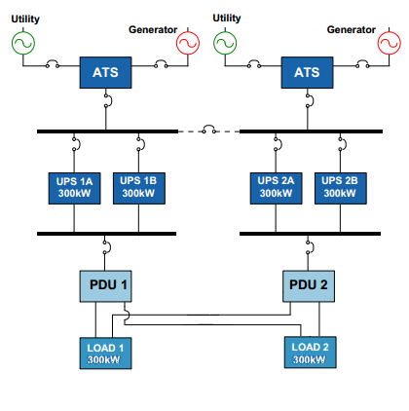

ATS = Automatic transfer switch

PDU = Power distribution unit

## Advantages

Scalability, flexibility, cost efficiency and stability:

Virtualization makes it possible to create a VM within a minute. Adding vCPUs and RAM to an existing VM is as simple as a reboot of the virtual server.

Using virtualization enabling a single physical server to host many virtual servers that previously would have required many physical servers. This will save power and increase the efficiency of server resources.

Simplify operations by leveraging the ability to migrate workloads dynamically between hosts. Therefore, the workload SLA can automatically match capacity demands. In addition, you can perform maintenance without disrupting business services.

The possibility for facilitating disaster recovery operations by easily switching to a different datacenter (on a different location).

## Disadvantages

The following disadvantages of virtualization are the following:

* Some of the IT employees of Plaintech might need a training so they will be able to maintain the new virtual platform.

## Assumptions

* We assume that the platform that Plaintech currently has, will be replaced for the new Linux-based platform.
* We assume that we don’t have to calculate any form of growth in our business plan.
* We assume that Plaintech has 50.000 customers who pay €40 each month on average.
* We assume that the average customer uses 100GB of storage and 4GB RAM.
* We assume that we don’t have to calculate any form of datacenter costs.
* We assume that the economic depreciation is 7 years.

## Costs

What are the initial costs and what are the monthly costs of the project?

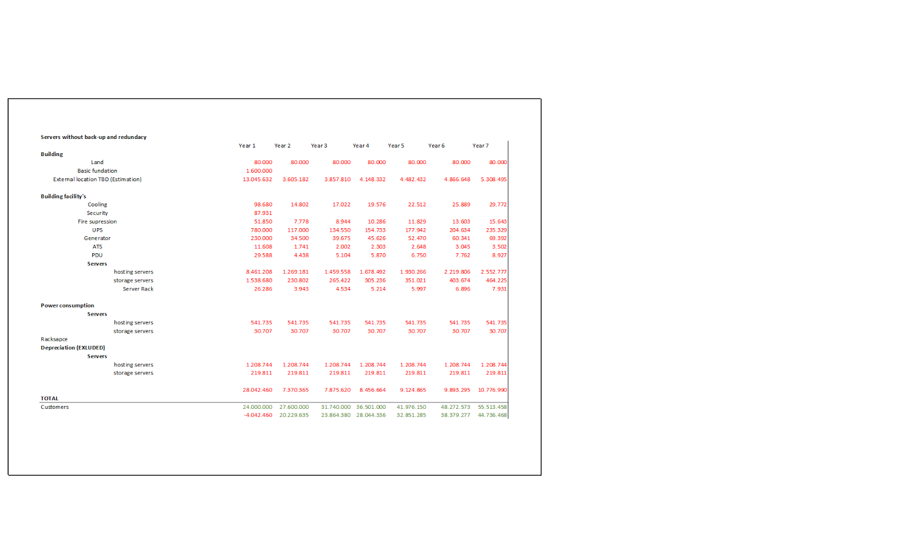

## Investment Analysis

If the benefits exceed the costs, the business case will be achievable. As seen in the above cost-table, the income is greater than the costs itself. Therefore, the business case is achievable.

* 1. **Return on investment**

|  |  |  |  |  |
| --- | --- | --- | --- | --- |
| **Year** | **Customers\*** | **Costs** | **Income** | **ROI** |
| Year 1 | 50000 | €28.042.460 | €24.000.000 | -14% |
| Year 2 | 57500 | 7.370.365 | 27.600.000 | 274,27% |
| Year 3 | 66125 | 7.875.620 | 31.740.000 | 303% |

*Growth not included

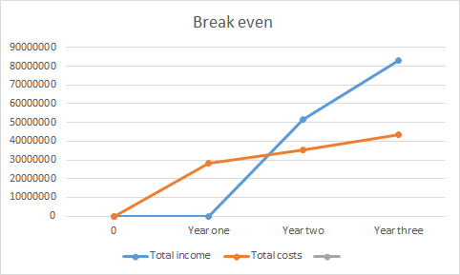

# Project organization

## Organisational chart

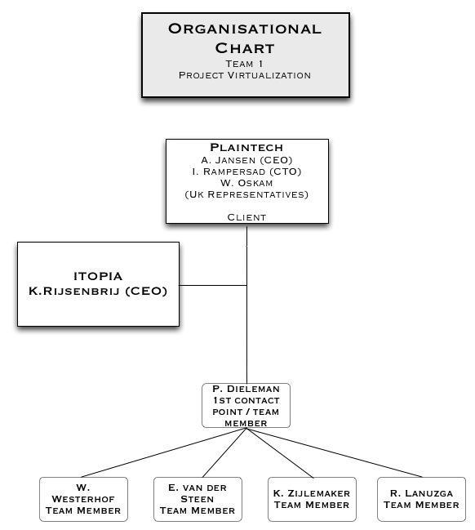

## Roles & responsibilities

***Project Team (1)***

Our team exists out of 5 members that take full responsibility for Project virtualization. Each team member has been designated with a task that they must fulfil during the whole project. Our task is to create a product for Plaintech.

|  |  |  |
| --- | --- | --- |
| **Team 1** |  |  |
| **Name** | **Role / Responsibility** | **Contact** |
| Pieter Dieleman | Team Member | Pieter.Dieleman@hva.nl |
| Willem Westerhof | Team Member | willem.westerhof@hva.nl |
| Kjell Zijlemaker | Team Member | Kjell.Zijlemaker@hva.nl |
| Eddy van der Steen | Team Member | Eddy.van.der.Steen@hva.nl |
| Rodney Lanuzga | Team Member | Rodney.Lanuzga@hva.nl |

The client is the head of the project and is responsible for providing us with the correct information so that we can create a proper product that meets their demands.

|  |  |  |
| --- | --- | --- |
| **Client** |  |  |
| **Name** | **Role / Responsibility** | **Contact** |
| Plaintech / A. Janssen | Client/CEO | a.jansen4@hva.nl |
| Plaintech/ W. Oskam | Client/CFO | w.oskam@hva.nl |
| Plaintech/ I. Rampersad | Client/CEO | i.m.rampersad2@hva.nl |

The project manager is responsible to report all information and progress to the client. He also gives us feedback in how we can improve so that we can satisfy the client.

|  |  |  |
| --- | --- | --- |
| **Project manager** |  |  |
| **Name** | **Role / Responsibility** | **Contact** |
| A. Jansen | Project manager | a.jansen4@hva.nl |

The responsibility of the coach is to support the team in case there are issues or disagreements. He is also responsible for giving advice on how to work on the project in the most efficient way possible and to check if the communications between team members are going smoothly. During the coach meeting we will check if the project is going, as it should be.

|  |  |  |
| --- | --- | --- |
| **Coach** |  |  |
| **Name** | **Role / Responsibility** | **Contact** |
| Hendrik Hoogcarspel | Coach | h.hoogcarspel@hva.nl |

# Project plan

Throughout this project we will work with so called iterations. During such an iteration certain deliverables will be created, updated or finished. The exact planning of how to reach the goals of such an iteration will be made internally by the team members of this project at the start of an Iteration period. We have chosen this approach to remain as flexible as possible within the team while still providing Plaintech with a clear image regarding when to expect results.

## Plan assumptions

We assume that we only get 1 physical server to produce the proof of concept, In order to get as close as possible to the real situation we will use Virtual machines. This way we can prove that our concept works and explain how it can be ported to the systems of Plaintech. All documents such as the business case are based on the eventual situation as it will be for Plaintech. We also assume that our project team does not increase, nor decrease in size throughout the project.

## Graphical planning

*Included in appendices.(see appendix 1)*

## Product decomposition structure

First off we can splice this project into two parts.   
  
The documentation & The proof of concept.  
The documentation will include:  
Project Initiation Document*  
Functional Design*  
Technical Design*  
Implementation plan*  
  
The proof of concept product will be detailed by a MoSCoW approach:  
  
Must have:  
Website for plaintech*  
CRM system*  
Ability to create new virtual machines*  
Virtual networking*  
  
Should have:  
Daily backups*  
High availability*  
Security*  
  
Could have:  
off-site backup.*  
  
Won’t have:  
-  
*\*for the exact specifics of what is included in this document we recommend reading appendix 2.*

## Product flow chart

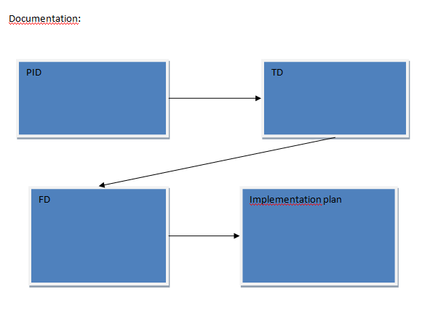

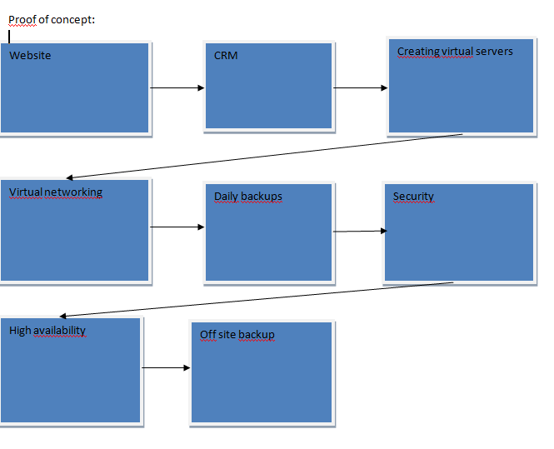

## Necessary resources

We can use the following resources, any other resources are prohibited unless otherwise agreed upon by the board members of plaintech:

- Assigned Dell hardware server

- Linux Debian

- Linux KVM

- Linux libvirt

- MySQL database server

- Apache Tomcat

- Apache Velocity

- Java

- HTML/HTML5/CSS

- Javascript/Dojo

- IDE Eclipse

## Product descriptions

In appendix 2 a detailed product description can be found for each deliverable noted in this document.

# Management tools

## Tolerances

For this project there is a hard deadline. This deadline is 13 January 2015. After this deadline no further contributions will be added to this product. We ourselves have internal deadlines a few days before the actual deadlines (as found in the graphical planning). This way we have a few days extra to help us out if any unexpected troubles are encountered.

## Risk management

In order to limit the risks we created our own system. In our planning we keep a flexible scheme so we can deal with unexpected issues. We also agreed to meet up 2 days each week to make sure knowledge is shared and difficult tasks can be worked on by multiple members.

|  |  |
| --- | --- |
| Example situations | Solution |
| Project members becomes ill | All tasks of this person are divided across the other team members. When this person is healthy again he will receive some additional work to even out the overall workload. |
| Missed internal deadline | The reason why this happened has to be made clear. In a team conversation the team decides how we proceed and feedback will be given to the responsible team member. A new deadline is then set. If for some reason this new deadline is again missed serious consequences will be determined based on the specific situation. |
| More work than expected/Too complex | If something turns out to be harder than we originally thought we will need some extra time. Because of our early deadlines we can take this extra time to solve the problem in time for the deliverable. |
| Project member stops with the educational program. | All tasks of this team member are divided across the team. All deadlines and workload are reviewed and edited when necessary. Also the missing team members work will be retrieved and reviewed for usability and commented so we can use it later in the project. |

## exception procedure

If at some point the project becomes uncontrollable because of risks, external factors or other reasons we will start a procedure. This procedure involves the entire team establishing contact with the project manager to discuss the current progress of the project and the reasons the project became uncontrollable. Based on this discussion a plan will be formed in order to regain control over the project and finish this project with deliverables as planned. If for some reason regaining control and finishing the project becomes impossible the project manager will contact the board members of Plaintech to discuss alternatives. The project manager will also contact the team members listed in this PID and explain the consequences to them.

## Progress reports

Contact between Plaintech and itopia will occur through e-mail and real life meetings. A new meeting will be scheduled at the end of each meeting. Progress reports through email will only occur if there are any deviations from the planning as discussed in the previous meeting, when a deliverable is ready to be reviewed, or when Plaintech requests a progress report by sending an email towards the members of team 1.

# Team Contract:

**Team cooperation contract project Virtualisation - team 1**

**Expectations:**

**Deadlines**:

* It is important that every team member completes his tasks/deadlines on time. However, if you somehow can’t complete your task within the determined amount of time, you will have to inform the team at least three days before the deadline. The deadlines will be determined in our meetings.

**Meetings***:*

* The team meetings are mandatory. We expect you to inform your team at least one day before the meeting if you are somehow prohibited from joining the meeting.

**Schedule***:*

* We will create and discuss our schedule during the project meetings. It might be updated if necessary.

In case that someone refuses to participate or repeatedly misses his deadline, we will start the procedure “Removal from team procedure” as explained in the project document.

**Documentation rules.**

* Titles in font size 14 and bold.
* Topic font 11 en bold.
* text font size 11.
* font Calibri, (“Tahoma” is optional in case calibri ain’t available .).
* Use Interpunction.
* Language: English

**Team members**:

|  |  |  |  |
| --- | --- | --- | --- |
| **Student** | **Mobile** | **Mail** | **Signature** |
| Pieter Dieleman | 06 - 18 43 67 59 | dielemanp@gmail.com |  |
| Willem Westerhof | 06 - 255 80 543 | www_willem@hotmail.com |  |
| Kjell Zijlemaker | 06 - 201 07 806 | kjell.zijlemaker@gmail.com |  |
| Eddy van der Steen | 06 - 426 58 720 | eddy.vdsteen@gmail.com |  |
| Rodney Lanuzga | 06 - 449 69 540 | lanuzgr001@hva.nl |  |

# Appendix 1. Graphical planning

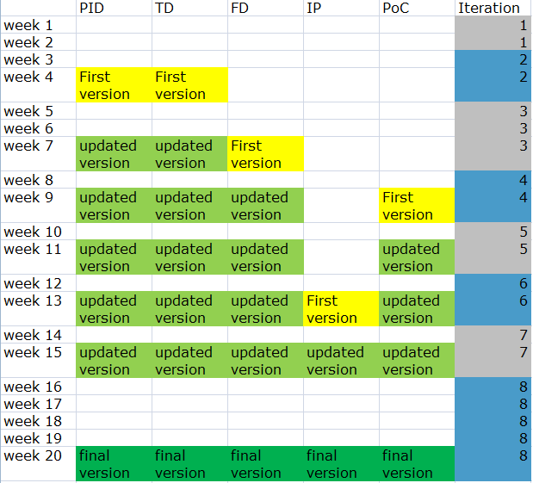

# Appendix 2. Productdescription

|  |  |
| --- | --- |
| Productdescription |  |
| Product ID | 001 |
| Productname | PID |
| Goal | The PID is written to form an agreement between Plaintech and Itopia. |
| Composition | Management summary Introduction Project definition Business case Project organisation Projectplan Management tools Team contract Appendixes |
| Knowledge and skill required to manufacture the product | Prince II concepts. The english language. Research required for the business case. |
| Quality criteria | As per Itopia quality control |
| Quality control | Senior Itopia personnel checks if the PID is up to the standards as agreed upon by Itopia. |

|  |  |
| --- | --- |
| Productdescription |  |
| Product ID | 002 |
| Productname | FD |
| Goal | To register how the product  is supposed to work, and what kind of behaviour is expected from the system. |
| Composition | Use case diagrams Scenarios Activitiy diagram |
| Knowledge and skill required to manufacture the product | UML skills English |
| Quality criteria | As per Itopia quality control |
| Quality control | Senior Itopia personnel checks if the PID is up to the standards as agreed upon by Itopia. |

|  |  |
| --- | --- |
| Productdescription |  |
| Product ID | 003 |
| Productname | TD |
| Goal | To reassure the Plaintech technical division that our configuration is possible, and to show an overview of necessary technology. |
| Composition | Network design Network configuration System design System configuration |
| Knowledge and skill required to manufacture the product | IP subnetting Archimate modelling Knowledge about the current network English |
| Quality criteria | As per Itopia quality control |
| Quality control | Senior Itopia personnel checks if the PID is up to the standards as agreed upon by Itopia |

|  |  |
| --- | --- |
| Productdescription |  |
| Product ID | 004 |
| Productname | IP |
| Goal | To provide Plaintech with information to implement our proof of concept on their actual systems. |
| Composition | Outcomes and end goal MoSCoW Project organization Roles and responsibilities Implementation scenario Implementations costs Implementation schedule Fallback scenario |
| Knowlegde and skill required to manufacture the product | Research English Knowledge of full scale system implementation |
| Quality criteria | As per Itopia quality control |
| Quality control | Senior Itopia personnel checks if the PID is up to the standards as agreed upon by Itopia |

|  |  |
| --- | --- |
| Productdescription |  |
| Product ID | 005 |
| Productname | PoC |
| Goal | The goal of the Proof of concept is to present a working product and proof that the product is working in accordance with the design and requirements for the management of Plaintech |
| Composition | Website CRM Scripts Virtual networks Daily backups Security High availability Off site backup |
| Knowledge and skill required to manufacture the product | Virtualization techniques  Skills with the IDE Eclipse  Knowledge about:  Linux  Apache (Tomcat, Velocity)  Java  HTML5, CSS  Javascript/Dojo |
| Quality criteria | As per Itopia quality control |
| Quality control | Senior Itopia personnel checks if the PID is up to the standards as agreed upon by Itopia |

# Appendix 3 SLA

**Service Level Agreement (SLA)**

**for *Plaintech***

**by**

Itopia

**Effective Date: 10-09-2014**

|  |  |
| --- | --- |
| **Document Owner:** | Itopia |

**Version**

|  |  |  |  |
| --- | --- | --- | --- |
| **Version** | **Date** | **Description** | **Author** |
| 1.0 | 10-09-2014 | Initial Service Level Agreement | Kjell Zijlemaker |
| **1.1** | 17-09-2014 | Update Service Level Agreement |  |
|  |  |  |  |

**Approval**

*(By signing below, all Approvers agree to all terms and conditions outlined in this Agreement.)*

|  |  |  |  |
| --- | --- | --- | --- |
| **Approvers** | **Role** | **Signed** | **Approval Date** |
| Itopia | Service Provider |  | 17-09-2014 |
| PlainTech | Customer |  | 17-09-2014 |

**Table of Contents**

1. Agreement Overview

2. Goals & Objectives

3. Stakeholders

4. Periodic Review

5. Service Agreement

5.1. Service Scope

5.2. Customer Requirements

5.3. Service Provider Requirements

5.4. Service Assumptions

6. Service Management

6.1. Service Availability

6.2. Service Requests

# 1. Agreement overview

This Agreement represents a Service Level Agreement (“SLA” or “Agreement”) between *Itopia* and PlainTech for the provisioning of IT services required to support and sustain the Product or service.

This Agreement remains valid until superseded by a revised agreement mutually endorsed by the stakeholders.

This Agreement outlines the parameters of all IT services covered as they are mutually understood by the primary stakeholders. This Agreement does not supersede current processes and procedures unless explicitly stated herein.

This agreement has three different SLA types available. These SLA types are graded from high to low as seen below:

* SLA type A
  + This SLA has the most commitments + high availability as seen in chapter 5
* SLA type B
  + This SLA has the second most commitments as seen in chapter 5
* SLA type C
  + This SLA has the least commitments as seen in chapter 5

# Goals & Objectives

The **purpose** of this Agreement is to ensure that the proper elements and commitments are in place to provide consistent IT service support and delivery to the Customer(s) by the Service Provider(s).

The **goal** of this Agreement is to obtain mutual agreement for IT service provision between the Service Provider(s) and Customer(s).

The **objectives** of this Agreement are to:

* + Provide clear reference to service ownership, accountability, roles and/or responsibilities.
  + Present a clear, concise and measurable description of service provision to the customer.
  + Match perceptions of expected service provision with actual service support & delivery.

# Stakeholders

The following Service Provider(s) and Customer(s) will be used as the basis of the Agreement and represent the **primary** **stakeholders** associated with this SLA:

**IT Service Provider(s):** Itopia. (“Provider”)

# Periodic Review

This Agreement is valid from the Effective Dateoutlined herein and is valid until further notice. This Agreement should be reviewed at a minimum once per fiscal year; however, in lieu of a review during any period specified, the current Agreement will remain in effect.

The Project team is responsible for facilitating regular reviews of this document. Contents of this document may be amended as required, provided mutual agreement is obtained from the primary stakeholders and communicated to all affected parties. The project team will incorporate all subsequent revisions and obtain mutual agreements / approvals as required.

**Business Relationship Manager:** Plaintech

**Review Period:** Bi-Yearly (6 months)

**Previous Review Date:** 10-09-2014

**Next Review Date:** 10-03-2015

# Service Agreement

The following detailed service parameters are the responsibility of the Service Provider in the ongoing support of this Agreement. Grade A is the agreement with the most services included.

## *Service Scope*

The following Services are covered in the grade C agreement;

## *Basic System*

## *Monitored email support*

* + Monthly system health check

The following Services are covered in the grade B agreement;

## *Basic System*

## *Daily backup*

## *Manned telephone support*

## *Monitored email support*

* + Monthly system health check

The following Services are covered in the grade A agreement;

## *Basic System*

## *Daily backup*

## *High availability with redundancy*

## *Manned telephone support*

## *Monitored email support*

* + Remote assistance
  + Monthly system health check

## *Customer Requirements*

**Customer** responsibilities and/or requirements in support of this Agreement include:

* Payment for all support costs for one of the SLA levels:
* Basic System
* Basic System + daily backup
* Basic System + daily backup + high availability (redundancy)
* Reasonable availability of customer representative(s) when resolving a service related incident or request.

## *Service Provider Requirements*

Service Provider responsibilities and/or requirements in support of this Agreement include:

* Average response time from 24 hours through a week, associated with incidents
* Appropriate notification to Customer for all scheduled maintenance.

## *Service Assumptions*

Assumptions related to in-scope services and/or components include:

* Changes to services will be communicated and documented to all stakeholders.

# Service Management

Effective support of in-scope services is a result of maintaining consistent service levels. The following sections provide relevant details on service availability, monitoring of in-scope services and related components.

## *Service Availability*

Coverage parameters specific to the service(s) covered in this Agreement are as follows:

* Telephone support : 9:00 A.M. to 5:00 P.M. Monday – Friday
  + When there are no telephones available, the customer is called back as soon as possible
* Email support: Monitored 9:00 A.M. to 5:00 P.M. Monday – Friday
  + Emails received outside of office hours will be collected and answered as soon as possible

## *Service Requests*

In support of services outlined in this Agreement, the Service Provider will respond to service related incidents and/or requests submitted by the Customer within the following time frames:

* 0-8 hours (during business hours) for issues classified as **High** priority.
* Within 48 hours for issues classified as **Medium** priority.
* Within 5 working days for issues classified as **Low** priority.

Remote assistance will be provided in-line with the above timescales dependent on the priority of the support request.